1903299 Connor Murphy Feasibility Demo
Gantt chart
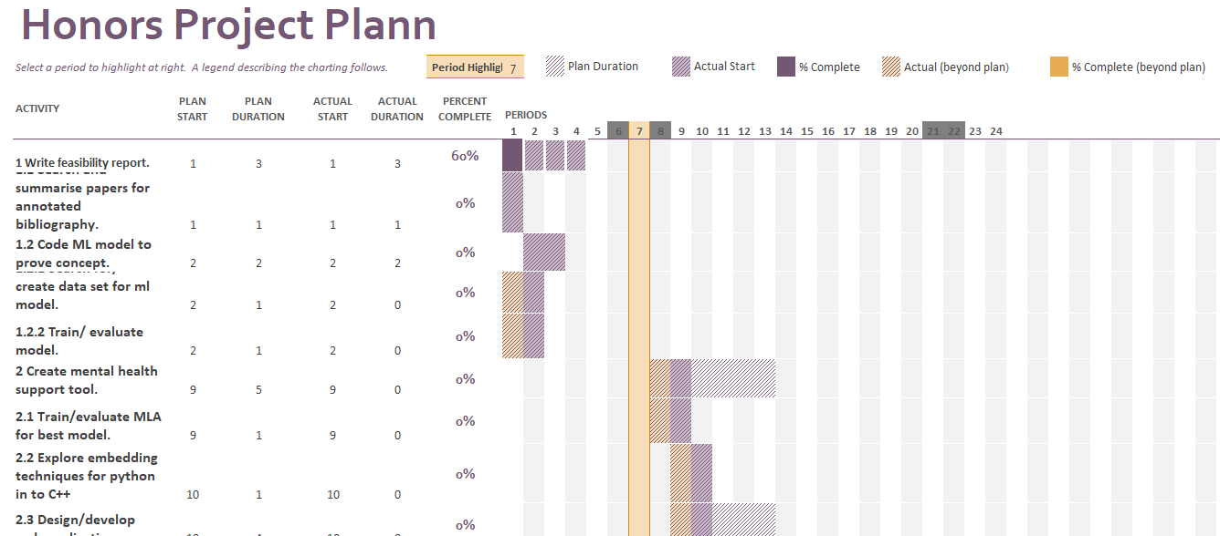
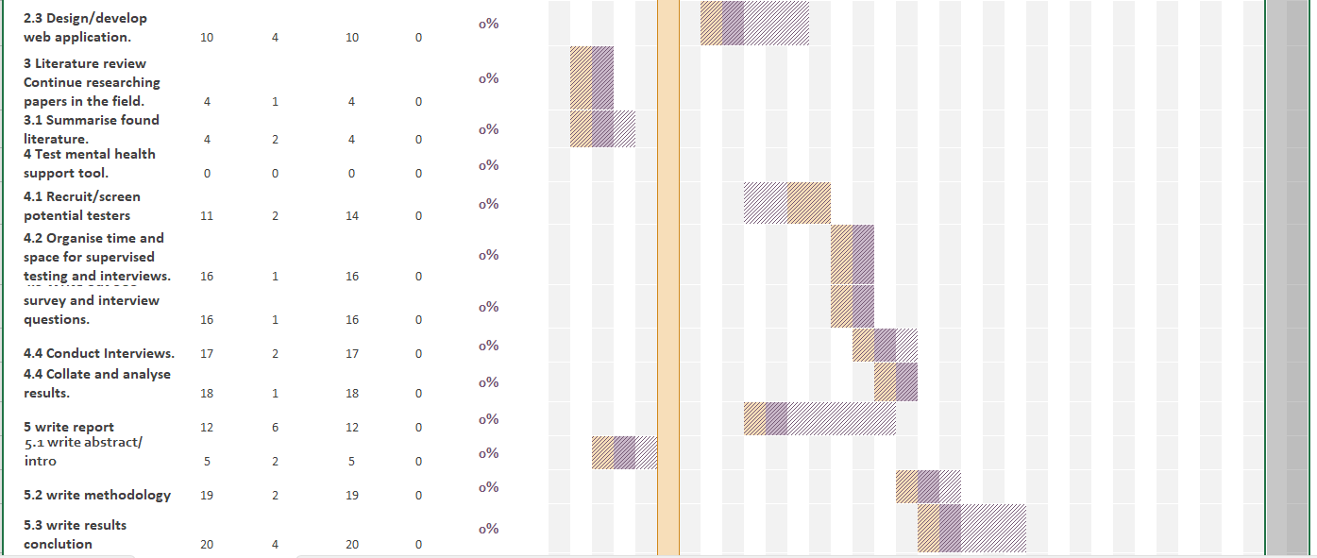
Full Excel file uploaded along with this document.

Risk analysis
Risk | Likely Hood | Consequence | Severity | Strategy
Not having enough testers to properly evaluate the application | 2 | 5 | 10 | Start recruit and screening testers as soon as possible.
Not being able to properly embed python into a c++ web application | 2 | 3 | 6 | C programs do have their own ml library. It does not allow for tuning so it will be a trade-off of ml quality for creating a finished tool for evaluating
Not being able to find a suitable data set to train the mla. | 1 | 4 | 4 | If no suitable data set can be made I will make my own using a keylogger and an environment that influence a certain mood on to me.
Personal sickness or injury | 1 | 5 | 5 | If I become sick for a week activity on the Gantt chart will be adjusted accordingly. If I become seriously ill the project will be proposed until a later date.
Supervisor sickness or injury | 1 | 2 | 2 | If the current Supervisor must leave for any reason. I will request a new supervisor. if one cannot be provided I will continue the project alone.
Unable to perform supervised testing | 2 | 3 | 6 | If supervised testing becomes impossible. I will have to sent the tester a copy of the application and multiple surveys and base my evaluation purely off of these surveys. Trusting the testers reported mood at the time of testing.
Loss of hardware/software | 1 | 5 | 5 | I will continually update project files on GitHub of similar
Assign a grading
R(ed)A(mber)G(reen)
• Red =11-15
• Amber = 6-10
• Green = 1-5

Research Question
Title: Evaluate suitability and usability of using a machine learning algorithm as a mental health support tool.
Aim: To Develop and Evaluate a mental health helper tool using machine learning as a base
Objectives:
- to obtain a suitable dataset with which to train the machine learning algorithm.
- to review different machine learning algorithm for accuracy and suitability for purpose.
- To develop a trained and tuned machine learning algorithm that predict mood based on typing data.
- To develop a application that takes in user typing data and uses the trained machine learning algorithm to predict the users current mood and give a positive supportive message.
- To organise supervised testing and interviews for testing on the application usability and suitability.
- To analyse and evaluate the data from the SUS survey and interviews.
- To report findings and recommend further application development or suggest a differ method to test.

Project changes
There are no major changes to the project since the project proposal.

Development code
# -*- coding: utf-8 -*-
"""
Created on Mon Mar 27 15:14:20 2023

@author: ninja
"""

# Importing the libraries
import matplotlib.pyplot as plt
import pandas as pd
from sklearn.metrics import confusion_matrix, zero_one_loss, roc_curve, auc
from sklearn.model_selection import train_test_split
from sklearn import preprocessing
import seaborn as sns # visualisation library
from sklearn.metrics import accuracy_score, classification_report, precision_recall_curve
from sklearn.multiclass import OneVsRestClassifier
import numpy as np

def print_score(features, target, clf, text):
# use the given model to predict on the given features
pred = clf.predict(features)

# produce a classification report using sklearn's methods
clf_report = pd.DataFrame(classification_report(target, pred, output_dict=True))

# display everything in a fomratted way
print(text, " Result:\n================================================")
print(f"Accuracy Score: {accuracy_score(target, pred) * 100:.2f}%")
print("_______________________________________________")

print(f"CLASSIFICATION REPORT:\n{clf_report}")
print("_______________________________________________")

cm = confusion_matrix(target, pred)
plt.figure()
sns.heatmap(cm, annot=True)

# can also write the cm as text
#print(f"Confusion Matrix: \n {cm}\n")

features_names = ['userId', 'emotionIndex', 'index', 'keyCode', 'keyDown', 'keyUp', 'D1U1', 'D1U2', 'D1D2', 'U1D2', 'U1U2', 'D1U3', 'D1D3', 'answer']

raw_data_filename = "typingdataset.csv"
raw_data = pd.read_csv(raw_data_filename, header=None, delimiter=",", names=features_names)

#Exploratory Data Analysis
raw_data = raw_data.iloc[1:]
raw_data = raw_data.drop('answer', axis=1)
raw_data = raw_data.drop('index', axis=1)
raw_data = raw_data.drop('userId', axis=1)
raw_data = raw_data.drop('keyCode', axis=1)
raw_data = raw_data.dropna()

raw_data['emotionIndex'] = raw_data['emotionIndex'].astype('int')
raw_data['keyDown'] = raw_data['keyDown'].astype('int')
raw_data['keyUp'] = raw_data['keyUp'].astype('int')
raw_data['D1U1'] = raw_data['D1U1'].astype('int')
raw_data['D1D2'] = raw_data['D1D2'].astype('int')
raw_data['D1U2'] = raw_data['D1U2'].astype('int')
raw_data['U1D2'] = raw_data['U1D2'].astype('int')
raw_data['U1U2'] = raw_data['U1U2'].astype('int')
raw_data['D1U3'] = raw_data['D1U3'].astype('int')
raw_data['D1D3'] = raw_data['D1D3'].astype('int')

print (raw_data.head())
print (raw_data.shape)
print (raw_data.info())
print (raw_data.describe())

#corr_matrix = raw_data.corr(numeric_only=False)
#sns.heatmap(corr_matrix, annot=True,method ='pearson')

#print (raw_data.isnull())
#print (raw_data.isnull())
#no nulls

#pwp = pd.plotting.scatter_matrix(raw_data, figsize=(50, 50), marker='0', edgecolor="k",
#hist_kwds = {'bins': 20, 'color':'blue'}, s=10, alpha=.8) # histogram and colours

cols = [ 'emotionIndex', 'keyDown', 'keyUp', 'D1U1', 'D1U2', 'D1D2', 'U1D2', 'U1U2', 'D1U3', 'D1D3']
X = raw_data.loc[:, cols].values
y = raw_data.loc[:,'emotionIndex'].values

#d = preprocessing.normalize(X)
#xnorm = pd.DataFrame(d, columns=cols)
#print(xnorm)

X_train, X_test, y_train, y_test = train_test_split(X,y, train_size=0.8, test_size=0.2)
print ("X_train, y_train:", X_train.shape, y_train.shape)
print ("X_test, y_test:", X_test.shape, y_test.shape)

from sklearn.ensemble import RandomForestClassifier

#create Classifier object
classif= OneVsRestClassifier((RandomForestClassifier(n_estimators = 20, random_state = 0, bootstrap = True, max_features="log2", oob_score= True)))

# fit the Classifier with x and y data
classif.fit(X_train, y_train)

y_pred = classif.predict(X_test) # crisp predictions (0 or 1)
y_probs = classif.predict_proba(X_test) # probability predictions between [0, 1]
#y_score = classif.decision_function(X_test)

fpr = {}
tpr = {}
thresh ={}

n_class = 5

for i in range(n_class):
fpr[i], tpr[i], thresh[i] = roc_curve(y_test, y_probs[:,i], pos_label=i)

# plotting
plt.plot(fpr[0], tpr[0], linestyle='--',color='orange', label='Class 0 vs Rest')
plt.plot(fpr[1], tpr[1], linestyle='--',color='green', label='Class 1 vs Rest')
plt.plot(fpr[2], tpr[2], linestyle='--',color='blue', label='Class 2 vs Rest')
plt.plot(fpr[3], tpr[3], linestyle='--',color='red', label='Class 3 vs Rest')
plt.plot(fpr[4], tpr[4], linestyle='--',color='black', label='Class 4 vs Rest')
plt.title('Multiclass ROC curve')
plt.xlabel('False Positive Rate')
plt.ylabel('True Positive rate')
plt.legend(loc='best')
plt.savefig('Multiclass ROC',dpi=300);
plt.plot

y_score = []
for n in range(len(y_test)):
label = y_test[n]
y_score.append(sum(y_probs[n,:])) #sum probabilities of all attack categories excluding normal
y_score = np.array(y_score)
precision, recall, thresholds_precision_recall = precision_recall_curve(y_pred, y_score, pos_label=1)
auc_pr = auc(recall, precision)

print_score(X_test, y_test, classif, 'test')
print_score(X_train, y_train, classif, 'train')

print ("Computing performance metrics")
error = zero_one_loss(y_test, y_pred)

# By definition, entry i,j in a confusion matrix is the number of observations actually in group i, but predicted to be in group j
print ("Error: ", error)

plt.figure()
plt.plot(recall, precision, label='AUC = %0.6f' % (auc_pr))
plt.xlabel('Recall')
plt.ylabel('Precision')
plt.xlim([-0.05, 1.05])
plt.ylim([-0.05, 1.05])
plt.title('Precision Recall curve (for detecting defects of any kind)')
plt.legend(loc="lower right", prop={'size': 'small'})
plt.savefig('Precision Recall curve for RF.png')
plt.savefig('Precision Recall curve for RF.pdf')
plt.show()

#testa = np.array([40, 1, 2, 140, 289, 0, 0, 172, 0, 0, -9, -9, -9])#0
#testA = preprocessing.normalize([testa])
#testb = np.array([48, 0, 4, 138, 214, 0, 0, 108, 1, 1.5, 2, -9, -9])#3
#testB = preprocessing.normalize([testb])
#testc = np.array([54, 0, 3, 130, 294, 0, 1, 100, 1, 0, 2, -9, -9])#4
#testC = preprocessing.normalize([testc])
#testd = np.array([49, 0, 3, 160, 180, 0, 0, 156, 0, 1, 2, -9, -9])#1
#testD = preprocessing.normalize([testd])
#teste = np.array([52, 1, 4, 120, 185, 0, 0, 155, 0, 0, -9, -9, -9])#2
#testE = preprocessing.normalize([teste])

#Test1= classif.predict(testA)
#Test2 = classif.predict(testB)
#Test3 = classif.predict(testC)
#Test4 = classif.predict(testD)
#Test5 = classif.predict(testE)

#print ("the first test should value 0. clasified as ", Test1)
#print ("the second test should value 3. clasified as ", Test2)
#print ("the third test should value 4. clasified as ", Test3)
#print ("the forth test should value 1. clasified as ", Test4)
#print ("the fifth test should value 2. clasified as ", Test5)

Annotated bibliography

Epp, C., Lippold, M. and Mandryk, R.L. (2011). Identifying emotional states using keystroke dynamics. Proceedings of the SIGCHI Conference on Human Factors in Computing Systems. doi: https://dl.acm.org/doi/pdf/10.1145/1978942.1979046?casa_token=NXOCS-Bk6U8AAAAA:vKJYMrpvqQibDsWXwqhRJTc8ZmDrY5tgvucl8FhsunFKTnNKsONqotxVZIksdstKib7uykhTTHw [Accessed on 06/11/2023]
In this paper Clayton Epp finds the users current emotional state out of a possible 15 using machine learning. The aim of this paper is to use keyboard dynamics to find the users emotional state. The method used to do this was to cod a C# program that ran in the background and collected keyboard interactions and every 10 minutes prompted the user to answer a question air to get their current mood. This data was then fed to a decision tree algorithm to classify them. The data collected was from participants during a normal day as to get a data set reminiscent of real-life conditions. This paper will be useful as it will inform no my design of the support tool and the setting of any testing of the tool. The main limitation of this paper was its data collection method. From the initial 50 participants only 12 generated enough varied data to be useful leading to “1129” rows which was further cut down after data cleaning. EPP and co found that “confidence, hesitance, nervousness, relaxation, sadness, and tiredness” could be accurately identified with “anger and excitement” being promising if with non-skewed data (the majority of times when surveyed anger was put as “Strongly disagree”). This paper will not form the basis of my project. However, it will be useful supplementary information for my designs on machine learning algorithm and the support tool.

A Mallej and I Kallel. (2020). Does Keystroke Dynamics tell us about Emotions? A Systematic Literature Review and Dataset Construction. [online] Available at: https://ieeexplore.ieee.org/document/9155004/authors#authors [Accessed 6 Nov. 2023].
In this paper Aicha Maalej reviews the data from the field of “emotion recognition through keystroke dynamics” over the past decade and through this develop a method of creating a data set for future use in the field. The main aim of the paper is to highlight the effectiveness of using keystroke dynamics to determine emotional state. By performing an SLR (Systematic Literature Review) on papers on the subject from the last decade. The scope of the literature review is any paper that meets their search criteria set out in the paper. For their data set collecting the application they used was open to the public, but they laid out the condition they guided the cleaning of the data for use later. This paper will be useful to this project by providing a method of creating a data set fit for use or providing one for use. The situation of this paper is the number of participants used to make the data set (4). This means that despite the high accuracy of the data it is not well generalised. Mallej concluded that more data sets need to be made with participants demographic data in mind. Also, that these new data sets should be properly labelled with appropriate feelings to encourage further research in the field. The data set from this article will be used to train my machine learning algorithm that will form the basis of the mental health support tool.

Kučera, D. and Haviger, J. (2012). Using Mood Induction Procedures in Psychological Research. Procedia - Social and Behavioral Sciences, 69, pp.31–40. doi: https://doi.org/10.1016/j.sbspro.2012.11.380. [Accessed 6 Nov. 2023].
In this article Dalibor Kučera reviews the different methods inducing a certain mood in a experimental participant focusing on negative emotions. The main aim of this article was to carry out and document mood induction methods on a large group. The experiment was conducted on 41 participants using different methods to induce 6 different moods (tired, happy, angry, sad, afraid, calm). The article is useful to the project Kučera suggests numerous methods for inducing moods. The main limitation of this article is that of blended emotions. The natural response to a given situation is to have a bland of multiple emotions not just one singular emotion. The methods from this article will be useful when any form of testing of the support tool for specific emotions/moods.

Creutzburg, R., (2017). The strange world of keyloggers-an overview, Part I. Electronic Imaging, pp.139-148. [online] Available at: https://www.researchgate.net/profile/Reiner-Creutzburg/publication/318228591_The_strange_world_of_keyloggers_-_an_overview_Part_I/links/597b8f65aca272d568b80559/The-strange-world-of-keyloggers-an-overview-Part-I.pdf [Accessed 6 Nov. 2023].
In this article Rineer Creutzburg gives a bibliographic overview of keyloggers that are available. The aim of the article is to review currently available keyloggers by evaluating the methods they use whether they be hardware or software based. The scope of the article includes keyloggers as used in malicious hacking attempts and security designed to counter act them. This article will be useful to the project as it shows examples of how to collect users keyboard dynamics for estimation from the machine learning algorithm. The limitation of this article is that it is just a review of current keyloggers and doesn’t go in to technical detail on how to produce them. There are no conclusion to be made in this article as it is just reviewing keyloggers not trying to answer any research question. This article will inform the keylogger aspect of the support tool by describing different methods of gathering key board dynamics.

Higgins, O., Short, B.L., Chalup, S.K. and Wilson, R.L. (2023). Artificial intelligence ( AI ) and machine learning ( ML ) based decision support systems in mental health: An integrative review. International Journal of Mental Health Nursing. doi: https://doi.org/10.1111/inm.13114. [Accessed 6 Nov. 2023].
In this paper Oliver Higgins and others explore the use of machine learning to guide mental health support in a real world and what obstacles may hold them back. The aim of the paper is to find evidence of machine learning used in real life mental health support settings. As well as find if there are any problems that might impede practical use of machine learning solutions. As previously stated this paper focuses on MLA that inform decisions on support and problems that may occur because of it. This paper will be useful to the project as it will highlight issues that the support tool may encounter. Which may be addressed during development of the tool. The limit of this paper is one of usable data. this is because after vetting only four studies were found to be fit for purpose. Higgins and other concluded that the main issues encounterd by MLA based decision support systems are clinicians' trust, confidence, and system transparency. Higgins suggested solution is to include the end users and every stage of development. By reading this paper I have concluded that this project needs a mental health professional to provide input that will help the support tool to be more readily acceptable by patients and doctors.

‌

‌

‌

Structure diagrams
Sequence Diagram
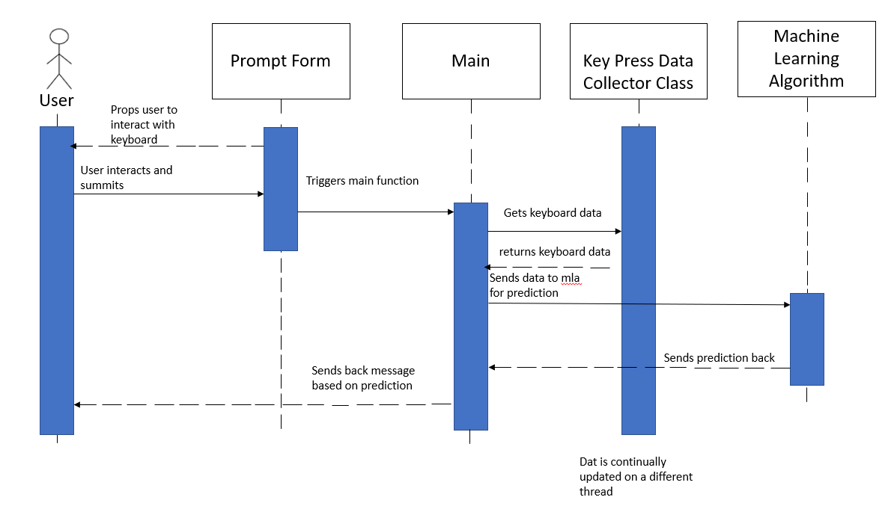
Class Diagram
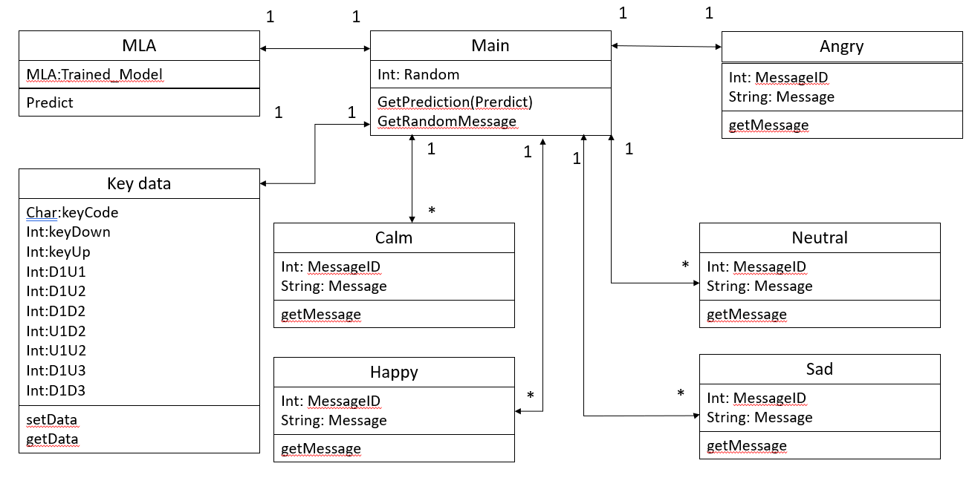

Wireframe of main page


